|  |  |
| --- | --- |
| **States** | **Values** |
| 0_cent_S | b0000 |
| 5_cent_S | b0001 |
| 10_cent_S | b0010 |
| 15_cent_S | b0011 |
| 20_cent_S | b0100 |
| 25_cent_S | b0101 |
| 30_cent_S | b0110 |
| 30_cent_S_2 | b0111 |
| 35_cent_S | b1000 |
| 35_cent_S_2 | b1001 |
| 40_cent_S | b1010 |
| 40_cent_S_2 | b1011 |
| 45_cent_S | b1100 |
| 45_cent_S_2 | b1101 |
| 50_cent_S | b1110 |

**State Transition Graph:**

The Double circled states in the graph are final states and revert back to initial state.

**Input bits:**

|  |  |
| --- | --- |
| Two input bits have been used to represent 0 cents, a nickel, a quarter and a dime. (**LSB bits**) | One input bit is for selecting 30 cent or 35 cent candy. (**MSB**) |
| b00: 0 cent | b0: 30 cent candy |
| b01: Nickle input | b1: 35 cent candy |
| b10: Dime Input |  |
| b11: Quarter Input |  |

**Output Bits:**

|  |  |
| --- | --- |
| Two output bits are reserved for no candy, 30 cent candy and 35 cent candy outputs. (**LSB bits**) | Two more bits are reserved for amount of change given back. (**MSB bits**) |
| b00: N/A | b00: No change |
| b01: No candy | b01: 5 cent change |
| b10: 30 cent candy | b10: 10 cent change |
| b11: 35 cent candy | b11: 15 cent change |

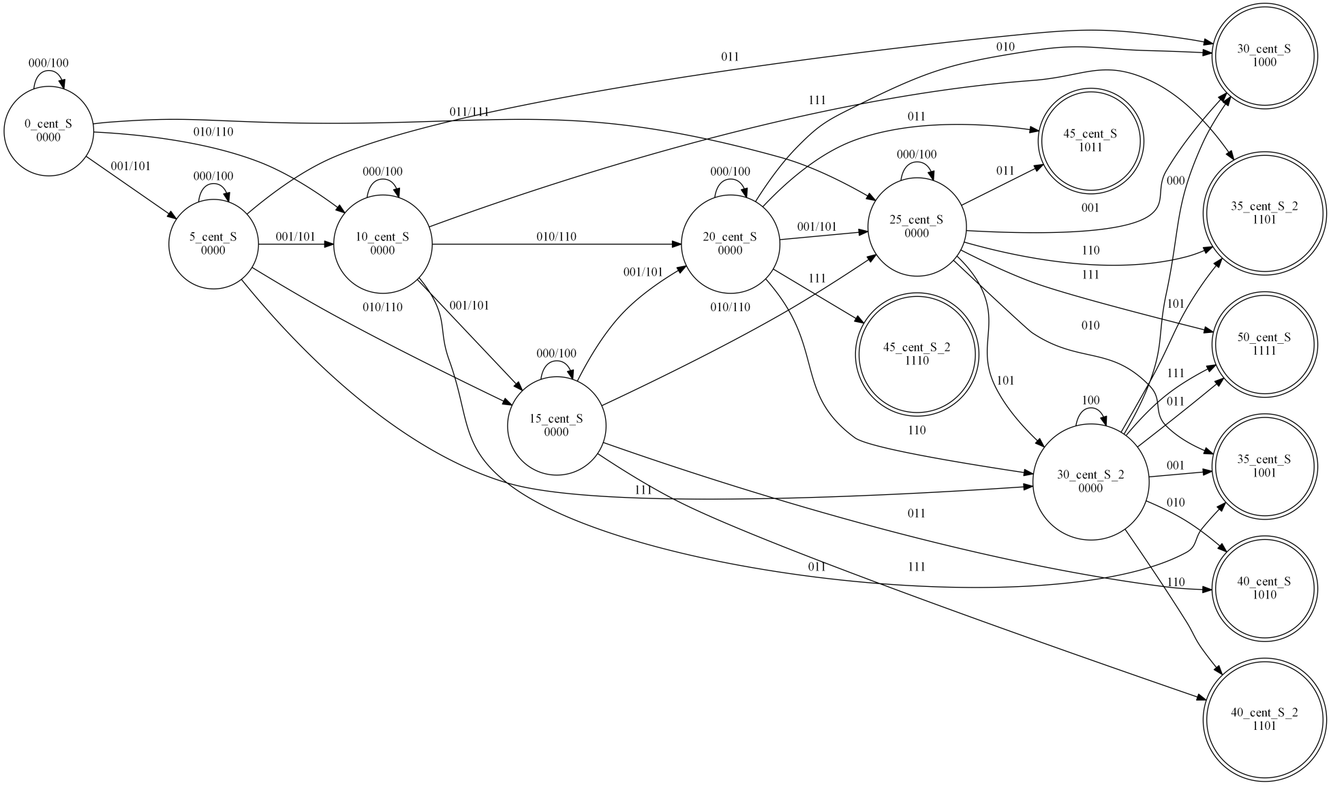

**Next state Table:**

|  |  |  |  |  |  |
| --- | --- | --- | --- | --- | --- |
| No. | Present State | Input Bits |  | Next State | Output |
|  |  |  |  |  |  |
| **0** | **0_cent_S** | **"000/100"** |  | **0_cent_S** | **"0000"** |
| **1** | **0_cent_S** | **"001/101"** |  | **5_cent_S** | **"0000"** |
| **2** | **0_cent_S** | **"010/110"** |  | **10_cent_S** | **"0000"** |
| **3** | **0_cent_S** | **"011/111"** |  | **25_cent_S** | **"0000"** |
| **4** | **5_cent_S** | **"000/100"** |  | **5_cent_S** | **"0000"** |
| **5** | **5_cent_S** | **"001/101"** |  | **10_cent_S** | **"0000"** |
| **6** | **5_cent_S** | **"010/110"** |  | **15_cent_S** | **"0000"** |
| **7** | **5_cent_S** | **"011"** |  | **30_cent_S** | **"1000"** |
| **8** | **5_cent_S** | **"111"** |  | **30_cent_S_2** | **"0000"** |
| **9** | **10_cent_S** | **"000/100"** |  | **10_cent_S** | **"0000"** |
| **10** | **10_cent_S** | **"001/101"** |  | **15_cent_S** | **"0000"** |
| **11** | **10_cent_S** | **"010/110"** |  | **20_cent_S** | **"0000"** |
| **12** | **10_cent_S** | **"011"** |  | **35_cent_S** | **"1001"** |
| **13** | **10_cent_S** | **"111"** |  | **35_cent_S_2** | **"1100"** |
| **14** | **15_cent_S** | **"000/100"** |  | **15_cent_S** | **"0000"** |
| **15** | **15_cent_S** | **"001/101"** |  | **20_cent_S** | **"0000"** |
| **16** | **15_cent_S** | **"010/110"** |  | **25_cent_S** | **"0000"** |
| **17** | **15_cent_S** | **"011"** |  | **40_cent_S** | **"1010"** |
| **18** | **15_cent_S** | **"111"** |  | **40_cent_S_2** | **"1101"** |
| **19** | **20_cent_S** | **"000/100"** |  | **20_cent_S** | **"0000"** |
| **20** | **20_cent_S** | **"001/101"** |  | **25_cent_S** | **"0000"** |
| **21** | **20_cent_S** | **"010"** |  | **30_cent_S** | **"1000"** |
| **22** | **20_cent_S** | **"011"** |  | **45_cent_S** | **"1011"** |
| **23** | **20_cent_S** | **"110"** |  | **30_cent_S_2** | **"0000"** |
| **24** | **20_cent_S** | **"111"** |  | **45_cent_S_2** | **"1110"** |
| **25** | **25_cent_S** | **"000/100"** |  | **25_cent_S** | **"0000"** |
| **26** | **25_cent_S** | **"001"** |  | **30_cent_S** | **"1000"** |
| **27** | **25_cent_S** | **"010"** |  | **35_cent_S** | **"1001"** |
| **28** | **25_cent_S** | **"011"** |  | **45_cent_S** | **"1011"** |
| **29** | **25_cent_S** | **"101"** |  | **30_cent_S_2** | **"0000"** |
| **30** | **25_cent_S** | **"110"** |  | **35_cent_S_2** | **"1100"** |
| **31** | **25_cent_S** | **"111"** |  | **50_cent_S** | **"1111"** |
| **32** | **30_cent_S_2** | **"000"** |  | **30_cent_S** | **"1000"** |
| **33** | **30_cent_S_2** | **"001"** |  | **35_cent_S** | **"1001"** |
| **34** | **30_cent_S_2** | **"010"** |  | **40_cent_S** | **"1010"** |
| **35** | **30_cent_S_2** | **"011"** |  | **50_cent_S** | **"1111"** |
| **36** | **30_cent_S_2** | **"100"** |  | **30_cent_S_2** | **"0000"** |
| **37** | **30_cent_S_2** | **"101"** |  | **35_cent_S_2** | **"1100"** |
| **38** | **30_cent_S_2** | **"110"** |  | **40_cent_S_2** | **"1101"** |
| **39** | **30_cent_S_2** | **"111"** |  | **50_cent_S** | **"1111"** |

**Shannon’s expansion:**

Assuming three input bits to be decomposed by the Shannon decomposition, leaving only state value bits in the truth table with 8x1 mux having three bit select lines from the input bits, following equations of 8 smaller circuits are produced at inputs of the mux.

Here “ABCD” are present state bits with A as MSB and D as LSB and “WXYZ” are output bits with W as MSB and Z as LSB. All the outputs are in minimized state.

**For select line 000:**

W = A' B C D;

X = 0;

Y = 0;

Z = 0;

**For select line 001:**

W = A' B D;

X = 0;

Y = 0;

Z = A' B C D;

**For Select line 010:**

W = A' B C' + A' B D;

X = 0;

Y = A' B C D;

Z = A' B C' D;

**For Select line 011:**

W = A' D + A' B' C + A' B C';

X = A' B C D;

Y = A' B C' + A' C D;

Z = A' B C' + A' B D + A' B' C D';

**For Select line 100:**

W = 0;

X = 0;

Y = 0;

Z = 0;

**For Select line 101:**

W = A' B C D;

X = A' B C D;

Y = 0;

Z = 0;

**For Select line 110:**

W = A' B D;

X = A' B D;

Y = 0;

Z = A' B C D;

**For Select line 111:**

W = A' B C' + A' C D + A' B' D';

X = A' B' C + A' B C' + A' C D;

Y = A' B C' + A' B D;

Z = A' B D + A' C D;

**Final Circuit Diagram:**

8x1 multiplexeres

W

Equations of W output bit

X

Y

Z

Equations of Z output bit

Equations of Y output bit

Equations of X output bit